Join us and be a part of a growing number of Sun City Residents interested in the preservation and display of Vintage vehicles of all types.

Make network contacts with like-minded people who will be eager to help with advice and resources to make your restoration project fun and successful.

Show your vehicle at the club cruise-ins and other events to share your pride of ownership of unique vehicles in a friendly and welcoming atmosphere.
_______________________________________________________________________________________________________________

More info or register on our website:
www.vintagevehiclesofsuncity.com
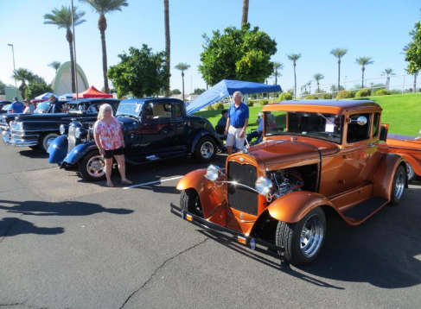

PLACE
STAMP
HERE

Vintage Vehicles of Sun City | 13430 N 105th Ave. Bldg. 17  Sun City, AZ 85351

The vision of the Vintage Vehicles of
Sun City Club is to provide a world class venue for Recreation Centers of Sun City Cardholders who have an interest in the restoration of cars, trucks and other projects. Formed in 2015, the Vintage Vehicle Club hopes to provide a clean and safe working and learning environment for its members, adding another unique amenity for residents of Sun City AZ.

In addition to restoration projects, the Club will conduct social and charitable activities such as car shows, cruises, picnics, and fund raisers.

The Vintage Vehicle Club of Sun City will provide another incentive for people to consider Sun City AZ for their retirement.
Upcoming Events

Membership Meetings every 3rd Tuesday at 1 PM at Lakeview Social Hall #1 & 2

Ongoing Breakfast Meeting will be every Thursday morning at Bobbie’s Café at 99th and Greenway - 7 AM

Every Wednesday - Cruise-In at the McDonalds at 99th and Bell 5 - 9 pm. One free drink or ice cream.

Contact Us:
623-215-8312
vintagevehiclesofsuncity.com
vvsuncity@outlook.com

President: Troy Janicki troyjanicki@gmail.com

Vice President #1: Bill Senter
wjsenter@yahoo.com

Vice President #2: Ed Gurski
evilways@cox.net

Treasurer: Roxie Whitney
ronald.whitney@gmail.com

Membership: Les Litzenberger
chiefles53@yahoo.com

Secretary:Yvonne Ahrens
y.ahrens@gmail.com

Events Director: Richard Holcomb
bethsmith70@hotmail.com

Membership Application | Please check one:
Primary Membership dues $25 | New Member
Second or Spouse Membership dues $10 | Renewal

Make Checks Payable To: VVSC
Only complete applications will be accepted.
Rec Card #’s will need to be verified before processing

Primary Name: __________________________________ Rec Card # __________
Verified: _______(initials)
Secondary Name: ________________________________Rec Card # __________
Verified: _______(initials)

Home Address ________________________________________________________

City _______________________State ___________________Zip _____________

Phone #: _______________________Email: ______________________________

Emergency Contact Name _____________________________________________

Phone #____________________________________________________________

Areas of Interest, Special Skills, Experience:

___________________________________________________________________

___________________________________________________________________

Cars, Trucks other projects:

___________________________________________________________________

___________________________________________________________________

___________________________________________________________________

Date Dues Paid: ___________ Amount Paid/How: ____________ For Year: ______

Received by:(print) _____________________ (sign) _________________________

